Assignment No: 2
Name: DHARUN I
Register No: 211519205043
Domain Name: PLASMA DONOR APPLICATION
PROJEC ID: PNT2022TMID26173

DOMAIN NAME : CLOUD APPLICATION DEVELOPMENT
QUESTION 1,2:
OUTPUT:
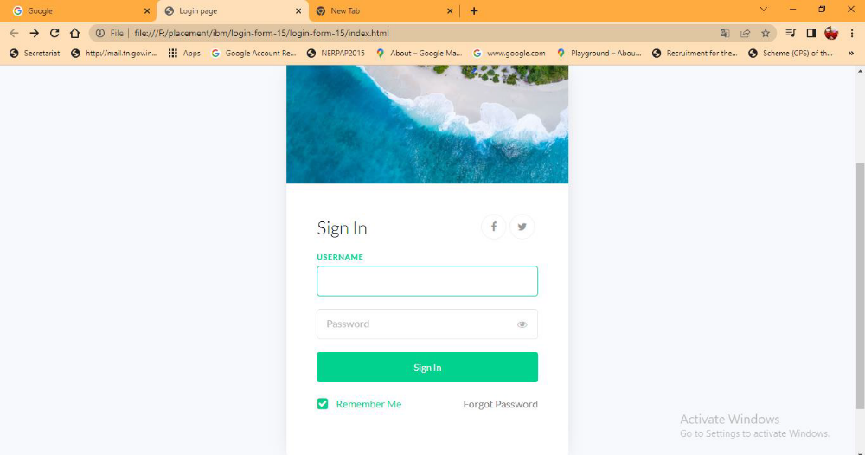

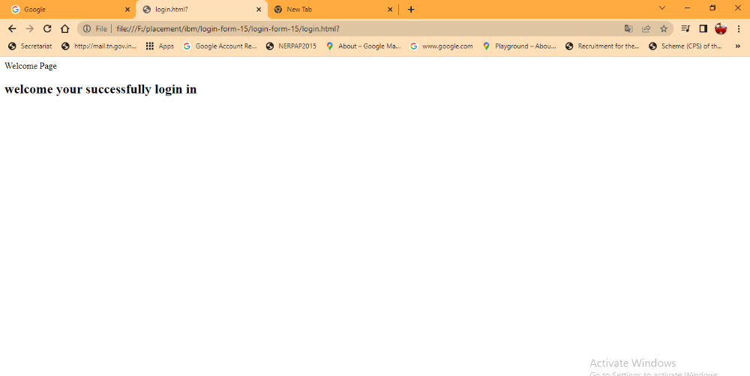
QUESTION 3:
LOGIN.HTML
<html>
<body>
<form action = "http://localhost:5000/login" method = "get">
<table>
<tr><td>Name</td>
<td><input type ="text" name ="uname"></td></tr>
<tr><td>Password</td>
<td><input type ="password" name ="pass"></td></tr>
<tr><td><input type = "submit"></td></tr></table>
</table>
</form>
</body>
</html>
EG.py:
from flask import *
app = Flask(__name__)
@app.route('FLASK GET METHOD.HTML',methods = ['GET'])
def login():
uname=request.args.get('uname')
passwrd=request.args.get('pass')
if uname=="ruby" and passwrd=="123":
return "Welcome %s" %uname
if __name__ == '__main__':
app.run(debug = True)

